参看：https://blog.csdn.net/simatongming/article/details/76021687

http://www.phperblog.cn/1295/

UserExample.Criteria criteria = userExample.createCriteria(); //构造自定义查询条件

区分逆向工程和自定义的

比如类和有关系，用扩展类接受后，不会影响删除逆向工程

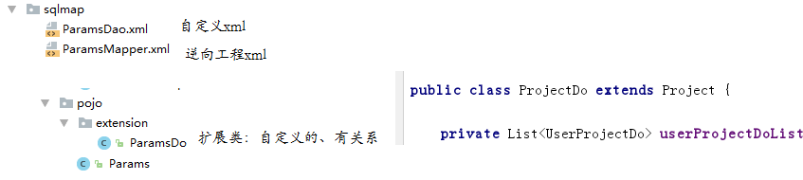

# 介绍

## mapper接口中的方法解析



## example实例解析

mybatis的逆向工程中会生成实例及实例对应的example，example用于添加条件，相当where后面的部分

xxxExample example = new xxxExample();

Criteria criteria = new Example().createCriteria();



## 应用举例

### 查询

1. selectByPrimaryKey()

User user = XxxMapper.selectByPrimaryKey(100); //相当于select * from user where id = 100

1. selectByExample() 和 selectByExampleWithBLOGs()

UserExample example = new UserExample();

Criteria criteria = example.createCriteria();

criteria.andUsernameEqualTo("wyw");

criteria.andUsernameIsNull();

example.setOrderByClause("username asc,email desc");

List<?>list = XxxMapper.selectByExample(example);

//相当于：select * from user where username = 'wyw' and username is null order by username asc,email desc

注：在iBator逆向工程生成的文件XxxExample.java中包含一个static的内部类Criteria，Criteria中的方法是定义SQL 语句where后的查询条件。

### 插入数据

insert()

User user = new User();

user.setId("dsfgsdfgdsfgds");

user.setUsername("admin");

user.setPassword("admin")

user.setEmail("wyw@163.com");

XxxMapper.insert(user);

//相当于：insert into user(ID,username,password,email) values ('dsfgsdfgdsfgds','admin','admin','wyw@126.com');

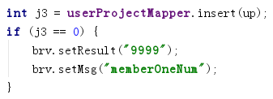

### 更新数据

1. updateByPrimaryKey()

User user =new User();

user.setId("dsfgsdfgdsfgds");

user.setUsername("wyw");

user.setPassword("wyw");

user.setEmail("wyw@163.com");

XxxMapper.updateByPrimaryKey(user);

//相当于：update user set username='wyw', password='wyw', email='wyw@163.com' where id='dsfgsdfgdsfgds'

1. updateByPrimaryKeySelective()推荐

User user = new User();

user.setId("dsfgsdfgdsfgds");

user.setPassword("wyw");

XxxMapper.updateByPrimaryKey(user);

//相当于：update user set password='wyw' where id='dsfgsdfgdsfgds'

1. updateByExample() 和 updateByExampleSelective()

UserExample example = new UserExample();

Criteria criteria = example.createCriteria();

criteria.andUsernameEqualTo("admin");

User user = new User();

user.setPassword("wyw");

XxxMapper.updateByPrimaryKeySelective(user,example);

//相当于：update user set password='wyw' where username='admin'

updateByExample()更新所有的字段，包括字段为null的也更新，建议使用 updateByExampleSelective()更新想更新的字段

### 删除数据

1. deleteByPrimaryKey()

XxxMapper.deleteByPrimaryKey(1); //相当于：delete from user where id=1

1. deleteByExample()

UserExample example = new UserExample();

Criteria criteria = example.createCriteria();

criteria.andUsernameEqualTo("admin");

XxxMapper.deleteByExample(example);

//相当于：delete from user where username='admin'

### 查询数据数量

countByExample()

UserExample example = new UserExample();

Criteria criteria = example.createCriteria();

criteria.andUsernameEqualTo("wyw");

int count = XxxMapper.countByExample(example);

//相当于：select count(*) from user where username='wyw'

# 实例

## 条件查询

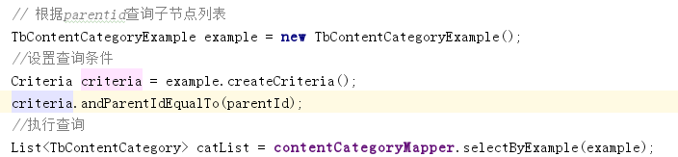



## 插入

去当前事务最后生成的主键

